Part 1: Encrypting Messages with OpenSSL

Step 1: Encrypting a Text File

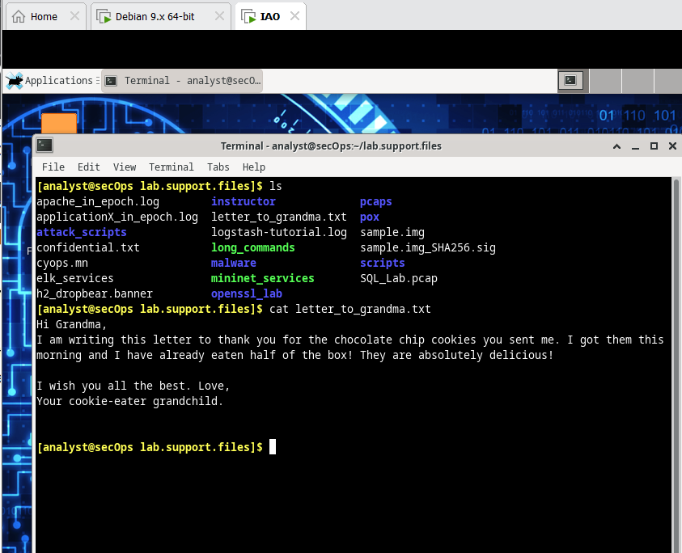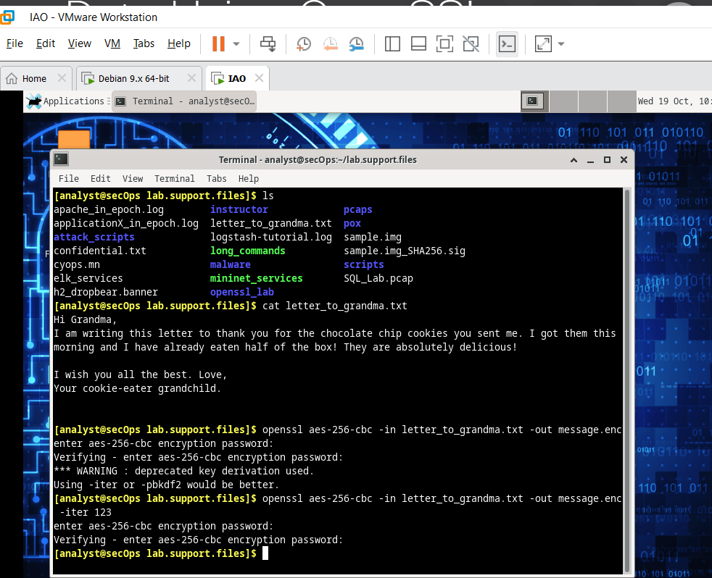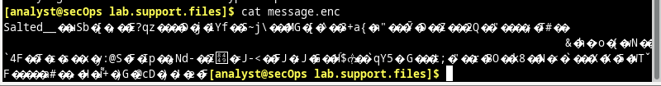Part 2: Decrypting Messages with OpenSSL

